UNIT - III FOOTINGS AND RAFTS
Part-A
1. Define Footing.
Footings are structural members, made of brickwork, masonry or concrete, used to transmit the load of the wall or column such that the load is distributed over a large area. The footings are of the following types:
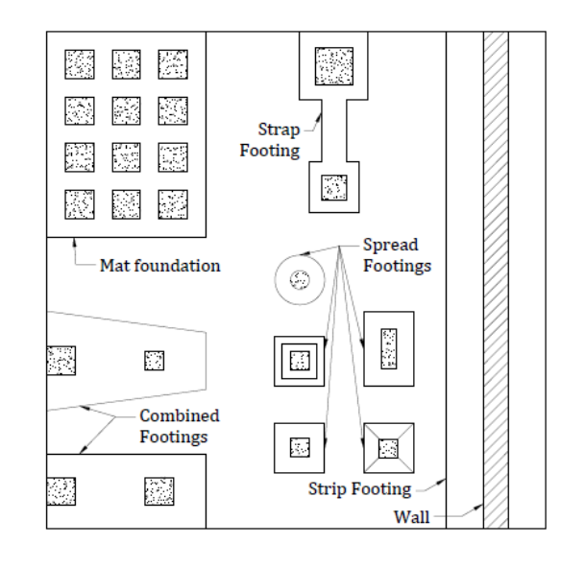
Property Line
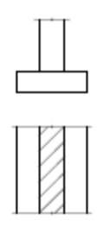
TYPES OF SHALLOW FOUNDATIONS
2. What is Strip footing? Under what circumstances it is provided?
- Provided for a load-bearing wall.
- Also provided for a row of columns which are so closely spaced that their spread overlap or nearly touch each other. In such a case it is more economical to provide a strip footing than to provide a number of spread footings in one line.
- Also known as continuous footing.

3. What is meant by Spread/Isolated/Pad footing? Under what circumstances it is provided?
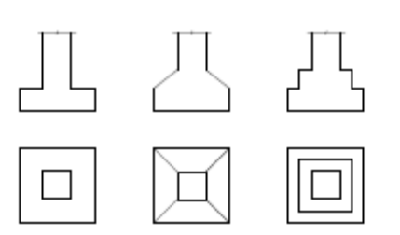
- Provided to support an individual column.
- A spread footing is circular, square or rectangular slab of uniform thickness.
- Sometimes it is stepped or haunched to spread the load over a large area.

4. What is a Combined footing? Under what circumstances it is provided?
- A combined footing supports two columns.
- It is used when the two columns are so close to each other that their individual footings would overlap.
- A combined footing is also provided when the property line is so close to one column that a spread footing would be eccentrically loaded when kept entirely within the property line. By combining it with that of an interior column, the load is evenly distributed.
- It may be rectangular or trapezoidal in plan.

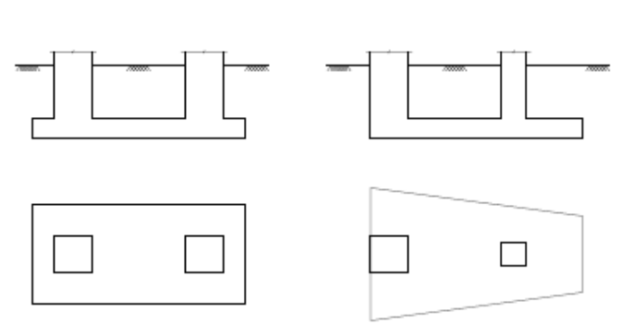

5. What is meant by Strap or cantilever footing? Under what circumstances it is provided?
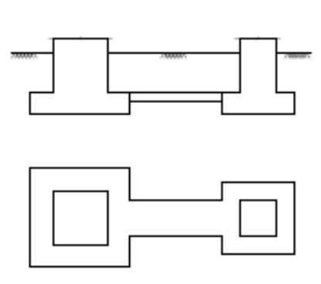
- It consists of two isolated footings connected with a structural strap or a lever.
- The strap connects the two footings such that they behave as one unit.
- The strap simply acts as a continuous beam and does not take any soil reaction.
- The individual footings are so designed that their combined line of action passes through the resultant of the total load.
- The strap is designed as a rigid beam.
- A strap footing is more economical than a combined footing when the allowable soil pressure is relatively high and the distance between the columns is large.
6. Define Mat or raft foundation.
- It is a large slab supporting a number of columns and walls under the entire structure or a large part of the structure.
- A mat is required when the allowable soil pressure is low or where the columns and walls are so close that individual footings would overlap or nearly touch each other.
- Useful in reducing the differential settlements on non-homogeneous soils or where there is a large variation in the loads on individual columns.

7. Write short notes on foundation loading/What are the various loads a foundation is subjected to?
An accurate estimation of all loads acting on the foundation should be made before it can be properly designed. A foundation may be subjected to one or more of the following loads:
- Dead Loads
- Live Loads
- Wind Loads
- Snow Loads
- Earth Pressure
- Water Pressure
- Earthquake loads
8. Write short notes on Computation of Loads in Foundation Design
The dead loads and live loads on columns are usually computed by tributary area method, in which it is assumed that a column carries the entire load in the floor area enclosed by lines equidistant from its adjacent columns.
Foundations shall be proportioned for the following combination of loads: [IS 1904 : 1986]
a) Dead load + live load, and
b) Dead load + live load + wind load or seismic load.
- Where wind or seismic load is less than 25% of that due to dead and live loads, it may be neglected in design and first combination of load (i.e, dead + live) shall be compared with the safe bearing load to satisfy allowable bearing pressure.
- Where wind or seismic load is more than 25% of that due to dead and live loads, foundations may be so proportioned that the pressure due to combination of load (i.e, dead + live + wind load) does not exceed the safe bearing capacity by more than 25%.
- Generally, one half of the design live load is taken as permanent.

9. Write short notes on principles of design of footing/ Write down the design procedure for a footing.
The footing is designed using the following procedure:
- Safe bearing capacity is determined.
- Footing is proportioned using the safe bearing capacity.
- Maximum settlement of the footing is determined. An estimate between differential settlement between various footings is made.
- Angular distortion is determined between various parts of the structure.
- The maximum settlement, differential settlement and angular distortion obtained in step (3) and (4) are compared with the given allowable values.
- If the values are not within the allowable limits, the safe bearing capacity is revised and the procedure is repeated.
- The stability of the footing is checked against sliding and overturning.
10. Brief contact pressure distribution/ Draw contact pressure distribution. (Separate questions may be asked)
The upward pressure due to soil beneath the footing is termed as contact pressure. The distribution of contact pressure depends upon a number of factors such as the elastic properties of the footing material and soil, the thickness of footings.
Contact pressure on cohesive soil:
- When the footing is flexible, it deforms into the shape of a bowel, with the maximum deflection at the centre. The contact pressure distribution is uniform.
- If the footing is rigid, the settlement is uniform. The contact pressure distribution is minimum at the centre and maximum at the edges.
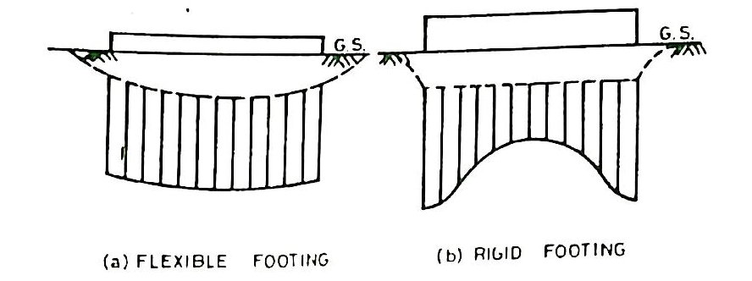
Contact Pressure on Cohesive Soil (Saturated Clay)
Contact pressure on cohesionless soil:
- In this case, the edges of the flexible footing undergo a larger settlement than at the centre. The soil at the centre is confined and, therefore, has a high modulus of elasticity and deflects less for the same contact pressure. The contact pressure is uniform.
- If the footing is rigid, the settlement is uniform. The contact pressure increases from zero at the edges to a maximum at the centre.
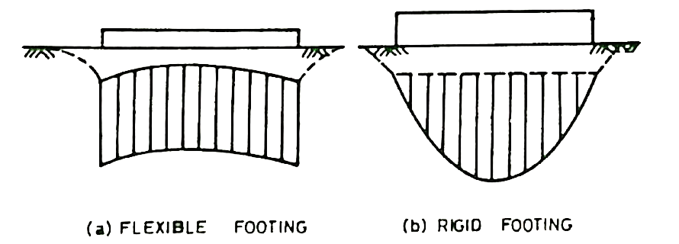
Contact Pressure on Cohesionless Soil (Sand)
Usual Assumption:
As discussed above, the contact pressure distribution for flexible footings is uniform for both cohesive and cohesionless soils. The contact pressure for rigid footing is maximum at the edges for footings on cohesive soils, but for rigid footings on cohesionless soils, it is minimum at the edges.

For convenience, the contact pressure is assumed to be uniform for all types of footings and all types of soils if load is symmetric
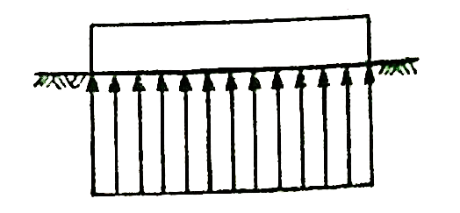
Uniform Contact Pressure
The above assumption of uniform pressure distribution will result in a slightly unsafe design for rigid footings on clays, as maximum bending moment at the centre is underestimated. It will give a conservative design for rigid footings on sandy soils, as the bending moment is overestimated. However, at the ultimate stage just before the failure, the soil behaves as an elasto-plastic material and the contact pressure is uniform, and the assumption is justified at the ultimate stage.

11. Briefly explain proportioning of isolated/spread footings
Isolated or spread footings are used for distributing concentrated column loads over a large area so that the bearing pressure is less than or equal to the allowable soil pressure.
For economical design, it is preferred to have square footing for vertical loads and rectangular footing for columns carrying moment.
The area of footing is given by
$$A=\frac{Q}{q_{na}}$$
Where Q = column load, q_{na} = allowable soil pressure
If the area actually provided is more, the actual pressure (q₀) is given by
$$q_{0}=\frac{Q}{Actual area}$$

12. Briefly explain proportioning of eccentrically loaded isolated/spread footings.
A column is said to be eccentrically loaded when it is subjected to a load which is not centric or when it is subjected to a bending moment in addition to the centric load.
If the centre of gravity of the footing is made to coincide with the centre of gravity of the centrically loaded column, the pressure distribution is trapezoidal, with the maximum pressure on one side and minimum pressure on the other side.
However, if the centre of gravity of the footing is placed eccentric with the centre of gravity of the column, the pressure distribution becomes uniform.
The eccentricity (e) of the footing is given by
$$e=\frac{M}{Q}$$
Where M = bending moment, and Q = axial load
If the footing is provided with the above eccentricity, the resultant of the bearing pressure coincides with the resultant of the loads. The area of the footing is given by
$$A=\frac{Q}{q_{na}}$$
The longer projection of the footing is designed as a cantilever for the maximum bending moment at the face of the column. Generally, the same reinforcement is provided in the smaller projection as well. The thickness provided is checked for the diagonal shear and punching shear.
The maximum pressure is determined using the following equations
$$q_{max}=\frac{Q}{L×B}\left(1+\frac{6e}{B}\right)$$
If e > B/6, the maximum pressure is given by
$$q_{max}=\frac{4Q}{3L(B-2e)}$$
The dimensions L and B of the footing are chosen such that the maximum pressure does not exceed that allowable bearing pressure. The bending moment, the diagonal shear and the punching shear are determined considering the trapezoidal pressure distribution.

13. State the circumstances where a rectangular combined footing is provided.
A combined footing is generally rectangular in plan if sufficient space is available beyond each column. If one of the columns is near the property line, the rectangular footing can still be provided if the interior column is relatively heavier.
If x’ = L/2, a rectangular footing is provided.
Where x’ = distance of the resultant from the outer face of the exterior column
L = is the length of the trapezoidal footing, determined from

14. State the circumstances where a trapezoidal combined footing is provided.
If the interior column is lighter, a trapezoidal footing is required to keep the resultant of the column loads through the centroid of the footing. Thus the resultant of the soil reaction is made to coincide with the resultant of the column loads.

A trapezoidal footing is required if
$$\frac{L}{3}<x^{'}<\frac{L}{2}$$
Where x’ = distance of the resultant from the outer face of the exterior column
L = is the length of the trapezoidal footing, determined from
However, if x’ < L/3, a combined footing cannot be provided. In such a case, a strap footing is suitable.
15. State the circumstances where a strap footing is provided. Write the assumptions made in the deisgn.
A strap footing is required in the following two cases:
- When x’ < L/3, where x’ is the distance of the resultant of column loads from the exterior face of the exterior column, and L is the length of the footing.
- When the distance between the two columns is so large that a combined footing becomes excessively long and narrow.
A strap footing consists of two spread footings joined by a rigid beam known as a strap. The strap is not subjected to any direct soil pressure from below. Its main function is to transfer the moment from the exterior footing to the interior footing.
Assumptions:
- The soil pressure is uniform beneath each individual footing.
- The strap is perfectly rigid.
- The strap is weightless.
- The interior footing is centrally loaded.

16. What are the different types of mat foundations?
- Flat Plate Type
- Flat Plate Thickened Under Columns
- Beam and Slab construction
- Box Structures
- Mats placed on Piles
17. Briefly explain the principles of design / design criterion for mat/raft foundation
Rafts on Cohesionless Soils: The bearing capacity of a foundation on cohesionless soils depends upon the width. As the width of a raft is very large, the bearing capacity is high, and, therefore, the shear failure generally does not occur. Accordingly, the safe settlement pressure, and not the bearing capacity, generally governs the design, except for very loose sands (N<5)
Rafts on Clay: In case of rafts on clay, as the safe bearing capacity is independent of its size, it generally governs the design. But the safe settlement pressure is also important in some cases. The settlements of rafts on normally consolidated clays are usually very large. However, in the case of over-consolidated clays, the settlements are small.

18. Write short notes on the design methods for mat foundations (separate questions may be asked)
The methods of design of mat foundations can be classified into 4 categories, depending upon the assumptions made.
1. Rigid Beam Method: In this method of design the slab is considered to be infinitely rigid as compared with the subsoil. The flexural deflections of mat in this case do not influence the contact pressure distribution acting on the mat. The pressure distribution is assumed to be planar. The centroid of the soil pressure coincides with the line of action of the resultant of all the loads acting on the slab.
This method is also known as conventional method of design.
2. Simplified Elastic Method: This method is based on the assumption that the soil behaves like an infinite number of individual independent elastic springs. The springs are assumed to take tension as well as compression. The assumption was first introduced by Winkler and foundation model is known as Winkler’s model. The method takes into account the elasticity of the footing. But as the soil does not behave exactly according to the assumptions made, the method is an approximate one and is a simplification of the actual soil behaviour.
The elastic constant of the spring is related to the coefficient of subgrade reaction.
3. Elastic Method: In this method of design, the soil is considered as homogeneous, linearly elastic half space. The method uses the solutions provided by the theory of elasticity. As actual soils do not behave as linearly elastic solids, this method also gives approximate solutions. The method is complicated and rarely used.
4. Non-linear Elastic Method: The soil is considered to be a non-linearly elastic solid. The method represents the behaviour of actual soil more closely than the elastic method and is more accurate. Numerical techniques, such as finite element method, are required for the design.

19. Define Coefficient of Subgrade Reaction.
The coefficient of subgrade reaction of a soil is the pressure required to produce a unit settlement of a plate. It is given by
$$k=\frac{q}{z}$$
where q = pressure (kN/m²), z = settlement (m), k = coefficient of subgrade reaction (kN/m³).
The coefficient of subgrade reaction is not a constant for a given soil. It depends upon a number of factors, such as length, width, depth and shape of foundation.

20. Write down Skempton’s Equation for finding net ultimate bearing capacity.
A raft on clay may fail in shear. The net ultimate bearing capacity can be determined from the following expression.
$$q_{nu}=5c\left[1+0.2\frac{D}{B}\right]\left[1+0.2\frac{B}{L}\right]$$
subject to the condition that D/B ≤ 2.5 or the factor$5\left[1+0.2\frac{D}{B}\right]$ does not exceed 7.5.
A factor of safety of 3 should be used to arrive at the safe bearing capacity. The danger of shear failure on sands is very remote and the settlement criterion governs the design.

21. What is meant by floating foundation?
A floating foundation for a building is defined as a foundation in which the weight of the building is approximately equal to the full weight including water of the soil removed from the site of the building.

The principle of a floating foundation is that, an exact balance of weight removed against weight imposed. The result is zero settlement of the building.

22. What are the problems to be considered in the design of a floating foundation?
The following problems are to be considered during the design and construction stage of a floating foundation.
- Excavation
- Dewatering
- Critical depth
- Bottom heave
PART-B
- Discuss different types of shallow foundations with its suitability.
- Discuss the method of proportioning of eccentrically loaded spread/isolated footings.
- Explain how proportioning of rectangular combined footing is done with a neat sketch.
- Explain how proportioning of trapezoidal combined footing is done with a neat sketch.
- Discuss the method of proportioning of strap/cantilever footings
- What are different types of raft/mat foundations? Discuss the procedure for the design of a raft/mat foundation.
- Discuss in details about the various problems to be considered in the design of a floating type mat foundations.
- Describe the procedure to proportion footings for equal settlement.
- A trapezoidal footing is to be provided to support two square columns of 30 cm and 50 cm sides respectively. Columns are 6 m apart and the safe bearing capacity of the soil is 400 kN/m2. The bigger column carries 5000 kN and the smaller 3000 kN. Design a suitable size of the footing so that it does not extend beyond the faces of columns.
- Proportion a rectangular combined footing for two columns 5 m apart. The exterior column of size 0.3 m X 0.3 m carries a load of 600 kN and interior column of size 0.4 m X 0.4 m carries a load of 900 kN. The allowable soil pressure is 100 kN/m2.
- Proportion a strap footing for two columns 6 m apart. The exterior column of size 0.4 m X 0.4 m carries a load of 600 kN and interior column of size 0.4 m X 0.4 m carries a load of 1000 kN. The allowable soil pressure is 100 kN/m2. Take the eccentricity of the footing of the column-1 as 1 m.
- A building is to be supported on a reinforced concrete raft covering an area of 14 x 21 metres. The subsoil is clay with an unconfined compressive strength of 84 kN/m². The pressure on the soil due to weight of the building and loads it will carry will be 120 kN/m² at the base of the raft. If the unit weight of excavated soil is 15 kN/m³, at what depth should the bottom of the raft be placed to provide a factor of safety of 3?
- A building is to be supported on 9 columns and the column loads are indicated. Determine te required area for the footings.
Column NO | 1 | 2 | 3 | 4 | 5 | 6 | 7 | 8 | 9
DL (kN) | 180 | 360 | 240 | 300 | 600 | 360 | 180 | 360 | 210
Max. LL(kN) | 180 | 400 | 210 | 300 | 720 | 360 | 120 | 300 | 180
At selected depth of 1.5 m, the allowable bearing capacity is 270 kN/m². Assume unit weight of concrete as 20 kN/m³.

